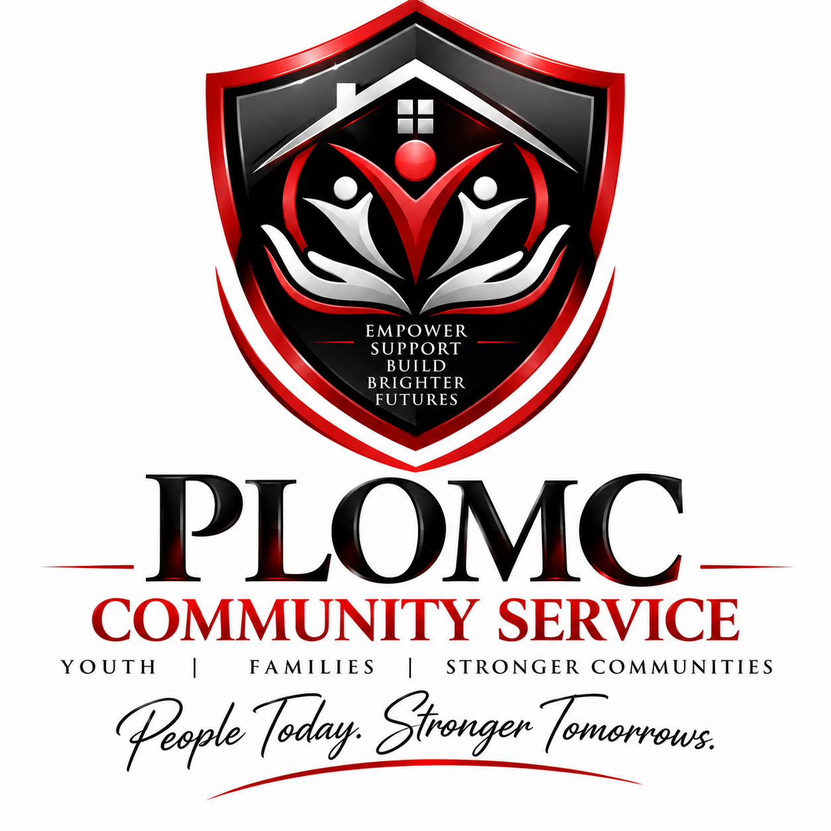

PLOMC
COMMUNITY SERVICE
YOUTH RESIDENTIAL PROGRAM
Formal Program Description
Proposed Non-Secure, Community-Based Residential Services
Nanticoke, Luzerne County, Pennsylvania
Prepared for program development, licensing review, referral-source presentation, and contracting
People Today. Stronger Tomorrows.

1. Organization and Program Overview
PLOMC Community Service is a service brand of PLOMC LLC. The proposed Youth Residential Program will provide structured, home-like, community-based residential services in Nanticoke, Pennsylvania. The program is being developed to support adolescents who require out-of-home placement, consistent adult supervision, stability, skill development, educational support, family engagement, and coordinated access to community resources.
The initial program concept is a small non-secure residential setting. Final licensed capacity, age range, resident profile, staffing ratios, and service classification will be established in consultation with the Pennsylvania Department of Human Services (DHS), Office of Children, Youth and Families (OCYF), local authorities, referral agencies, and applicable licensing requirements.
This program description is modeled in organization and level of detail on the sample program description supplied by the owner, including separate sections for services, admissions, family involvement, staffing, residential programming, life-skills development, supervision, and anticipated outcomes. It is intentionally written as PLOMC's own proposed program rather than copying the sample provider's policies.

2. Mission, Vision and Guiding Purpose

Mission
To provide youth with a safe, structured, respectful, and supportive residential environment that promotes stability, personal responsibility, education, healthy relationships, resilience, and preparation for successful family reunification or greater independence.

Vision
PLOMC Community Service envisions young people leaving residential care with stronger life skills, meaningful community connections, improved educational and employment readiness, and a realistic plan for a safe and productive future.

Core Commitments
- Safety and dignity in a home-like, least-restrictive environment.
- Trauma-responsive, youth-centered and culturally respectful services.
- Consistent structure, predictable routines and positive adult relationships.
- Family and supportive-adult engagement whenever permitted and clinically appropriate.
- Educational continuity and preparation for employment, vocational training or post-secondary education.
- Individualized planning based on each youth's strengths, needs, risks and permanency goals.
- Community integration, accountability, healthy decision-making and developmentally appropriate independence.

3. Proposed Population and Residential Model
PLOMC's first residential home is proposed as a small, non-secure program serving adolescents. For initial planning purposes, PLOMC is considering approximately six beds. PLOMC will finalize the licensed age range after OCYF confirms the applicable program classification. The preferred first-home model is focused on adolescents rather than combining young adolescents and adults in one residence.

Youth may be referred by county Children and Youth Services agencies, juvenile probation/court systems when appropriate to the approved program, or other authorized referral entities. Admission will be based on the program's approved license, contract requirements, bed availability, compatibility with the existing resident population, and PLOMC's ability to safely meet the youth's identified needs.

4. Residential Services
Residents will receive 24-hour supervision and structured support. The residential environment will emphasize normalcy, consistency, healthy routines and opportunities to practice age-appropriate skills. Services are expected to include:
- Safe housing, meals, clothing coordination and assistance with basic daily needs.
- 24-hour awake/scheduled staff coverage consistent with applicable regulations and individualized supervision needs.
- Individual service planning and regular progress review.
- Educational enrollment, attendance monitoring, homework support and coordination with schools.
- Life-skills instruction including cooking, cleaning, laundry, hygiene, household organization and time management.
- Financial literacy, budgeting, banking, credit awareness and consumer education for developmentally appropriate youth.
- Employment readiness, résumé preparation, interview practice, job-search support and vocational exploration for older adolescents.
- Transportation to school, approved family visits, medical appointments, court-related appointments, employment, community activities and other authorized services.
- Recreation, physical activity, community events, cultural experiences and structured leisure opportunities.
- Coordination with medical, dental, behavioral-health, substance-use, counseling and other professional providers when those services are required.
- Discharge, permanency and transition planning from the beginning of placement.

5. Life-Skills and Youth Development Curriculum
PLOMC will use structured individual and group learning opportunities to help residents practice skills that support healthy adulthood. Training content will be individualized according to age, developmental level, placement goals and assessed needs.
- Home management, meal planning, nutrition, grocery shopping and food preparation.
- Personal hygiene, preventive health, first aid awareness, home and fire safety.
- Communication, conflict resolution, emotional regulation and problem-solving.
- Healthy relationships, personal boundaries, human-trafficking awareness and personal safety.
- Time management, goal setting, decision-making and accountability.
- Money management, budgeting, banking, saving, credit and financial responsibility.
- Education planning, GED/vocational/post-secondary exploration where applicable.
- Career planning, job readiness, résumé writing, interviewing and employment retention.
- Community resources, public transportation and responsible community participation.
- Independent-living preparation for youth approaching adulthood.

6. Education and Employment Support
School participation will be treated as a central component of the residential program. PLOMC will coordinate with the placing agency, school district, educational decision-makers and other authorized parties to support timely enrollment, attendance, academic progress, special-education needs when applicable, and transition planning.
Older youth will be encouraged to explore employment, vocational programs, trade schools, apprenticeships and post-secondary education consistent with their service plan. Employment support may include job-search assistance, résumé development, interview preparation, workplace expectations, transportation planning and financial-literacy coaching.

7. Family and Supportive-Adult Engagement
PLOMC recognizes that safe, approved family and supportive-adult relationships can be important to permanency and successful transition. Family communication and visitation will be coordinated in accordance with court orders, the placing agency's instructions, the youth's service plan and applicable safety restrictions.
When authorized, PLOMC may facilitate telephone/video contact, on-site or community visits, transportation for approved visits, participation in service-plan meetings, and preparation for reunification or another permanency resource. Staff will not independently alter court-ordered or agency-approved contact restrictions.

8. Behavioral Support and Discipline Philosophy
The program is intended to operate as a structured, least-restrictive residential environment. PLOMC will emphasize positive behavioral support, relationship building, clear expectations, predictable routines, restorative problem-solving and developmentally appropriate consequences rather than punitive practices.
Corporal punishment, humiliation, threats, verbal abuse and other prohibited disciplinary practices will not be permitted. Crisis intervention and restrictive procedures, if applicable to the approved program, will be governed by Pennsylvania requirements, approved policies, staff training, individual plans and documentation requirements.
PLOMC intends to use a trauma-responsive approach that recognizes the potential effects of abuse, neglect, exploitation, instability, separation, community violence and other adverse experiences on behavior and development.

9. Admission and Intake

Proposed Admission Considerations
- Age and legal placement status consistent with PLOMC's approved license and contract.
- Need for a non-secure residential level of care that PLOMC is authorized and equipped to provide.
- Willingness and ability to participate in the residential program, with accommodations as required.
- Ability of PLOMC to safely address the youth's behavioral, medical, educational and supervision needs.
- Compatibility with the needs and safety of other residents.
- Availability of required records, authorizations and placement documentation.

Referral Review
Prior to admission, PLOMC will request and review available referral information, including placement history, legal status, education records, medical and medication information, behavioral-health history, risk and safety information, family/contact information, court orders, supervision needs and the placing agency's goals. An intake interview and pre-placement assessment will be completed before acceptance whenever circumstances permit.

Exclusion / Higher-Level-of-Care Considerations
PLOMC will not accept or retain a youth whose needs exceed the services, staffing, physical environment, security level or professional supports authorized for the program. Specific exclusion criteria will be finalized with OCYF and contracting agencies. Potential considerations may include an immediate need for inpatient psychiatric hospitalization, secure detention, medically intensive care, or other services outside PLOMC's approved scope.

10. Individual Service Planning and Case Coordination
Each resident will have an individualized service-planning process aligned with Pennsylvania requirements and the placing agency's case/permanency plan. The plan will identify strengths, needs, measurable goals, education, family involvement, health and behavioral-health services, life-skills priorities, supervision needs, transition objectives and discharge planning.
PLOMC staff will participate in authorized team meetings, communicate significant developments to the placing agency, document services and progress, and coordinate with schools, health providers, attorneys, probation personnel, family members and other authorized members of the youth's team.

11. Health, Behavioral Health and Medication
PLOMC will coordinate routine and urgent medical, dental, vision and behavioral-health services through appropriately licensed community providers unless PLOMC later becomes separately authorized to provide a regulated clinical service. Residents will receive assistance accessing appointments and transportation, and staff will maintain required health documentation.
Medication storage, administration, self-administration, documentation and staff training will follow applicable Pennsylvania requirements, prescriber instructions and PLOMC policy. Emergency and suicide-risk procedures will be established before opening.

12. Staffing Structure
The final organizational chart will be based on the approved license, resident population and contract requirements. The proposed structure includes:
- Owner/Managing Member - organizational oversight, fiscal responsibility and governance.
- Qualified Facility/Program Director - regulatory and program administration.
- Residential Supervisor/House Manager - day-to-day residential operations and staff supervision.
- Case Manager/Program Coordinator - service planning, documentation, team coordination and transition planning.
- Youth Care / Direct Care Workers - supervision, transportation, daily living support, activities, skill development and documentation.
- Relief/Per-Diem Staff - coverage for leave, call-outs, training and additional supervision needs.
- Contracted or community professionals - medical, behavioral-health, educational or specialized services when required.
PLOMC will maintain sufficient staffing for 24-hour operations and will not rely solely on minimum ratios when a resident's individualized needs, transportation demands, activities, emergencies or contract requirements require additional coverage.

13. Employee Screening, Clearances and Training
Before unsupervised work with residents, employees and contractors will complete all background checks, child-protection clearances, health screenings and other pre-employment requirements applicable to their role. PLOMC will maintain documentation of clearances and renewals as required.
Orientation and ongoing training will address, at minimum, mandated reporting, resident rights, supervision, trauma-responsive care, emergency procedures, fire safety, first aid/CPR as applicable, medication procedures where applicable, suicide prevention, crisis prevention/intervention, professional boundaries, documentation, confidentiality, cultural responsiveness, human trafficking awareness, missing-person/elopement response and other subjects required by regulation or contract.

14. Resident Rights, Culture and Religious Observance
PLOMC will respect each resident's legal and civil rights and provide services without unlawful discrimination. Residents will be treated with dignity and will have reasonable opportunities for religious observance, cultural expression and participation in approved community activities consistent with safety, court orders, agency direction and program rules.
A formal resident-rights policy, grievance process and complaint procedure will be provided at admission in a developmentally appropriate manner.

15. Recreation and Community Integration
Residents will have structured opportunities for recreation and positive community participation. Activities may include parks, libraries, sports and fitness, arts and cultural events, movies, community celebrations, volunteer opportunities, school events, youth-development programs, cooking projects, games and age-appropriate outings.
Activities will be selected based on resident interests, age, supervision needs, safety, available resources and individual service goals.

16. Transportation
PLOMC expects transportation to be an essential residential support. Transportation may include school, employment, medical and behavioral-health appointments, court or agency meetings, approved family visitation, recreation and community services. Drivers, vehicles, insurance, restraints, supervision and documentation will comply with applicable law, licensing standards and PLOMC policy.
Transportation services beyond the residential program's approved scope will not be represented as a separately licensed transportation service unless all additional requirements have been satisfied.

17. Safety, Emergency Preparedness and Incident Management
Before opening, PLOMC will maintain written emergency plans covering fire, severe weather, medical emergencies, missing/eloped youth, behavioral crises, suspected abuse, suicide/self-harm concerns, utility failure, evacuation, shelter-in-place, vehicle emergencies and continuity of operations.
Reportable incidents will be documented and communicated to DHS/OCYF, placing agencies, guardians, law enforcement or other parties as required. Staff will be trained on immediate protective actions, reporting timelines, internal review and corrective action.

18. Discharge, Permanency and Transition Planning
Discharge planning will begin at admission and will be coordinated with the placing agency and youth's team. Potential discharge outcomes may include family reunification, kinship/foster placement, another level of care, transition to an approved older-youth program, or independent/community living when legally and developmentally appropriate.
Prior to planned discharge, PLOMC will support continuity of education, medications and health services, identification documents, employment or training, transportation planning, community resources, family/support connections and other transition needs identified by the service plan.

19. Program Outcomes and Quality Improvement
PLOMC will track measurable outcomes appropriate to the resident population and contracts. Examples include:
- Placement stability and safe completion of the residential episode.
- School enrollment, attendance and educational progress.
- Reduction in significant safety incidents and successful use of coping/problem-solving strategies.
- Completion of individualized service-plan objectives.
- Development of age-appropriate daily living and financial-literacy skills.
- Improved family/supportive-adult engagement when permitted.
- Employment, vocational or post-secondary readiness for older youth.
- Successful reunification, permanency or transition to an appropriate next placement.
- Resident, family and referral-source feedback.
- Timeliness and quality of incident reporting, documentation, staff training and corrective actions.
Leadership will use incident trends, grievances, audits, stakeholder feedback, staff performance, training records and outcome data to identify opportunities for continuous quality improvement.

